L2 or L3 or tests name: IT-Operation Management
Legal entities in scope: DBAG, ExR, EFAG, ECAG, CBF, CBL, LuxCSD, CI, CS and CFCL
Capacity Management and Storage Management

[+ including AU-121-11-CSDR CSDR IT-Operation Management]

Test(s) according to RCA:

(TP1) Inquire with relevant personnel about the monitoring and reporting of the IT landscape capacity (per LE).
(TP2) Inspect related documents, i.e. presentations / reporting done regarding the IT landscape where the application identified as relevant for the audit are hosted, in order to validate continuous monitoring is performed and in case if needed, actions are taken.
(TP3) Inquire with relevant personnel about the storage management and storage allocation process.
(TP4) Inspect related documentation on the storage management process to understand and identify the controls established.
(TP5) Test the related controls with a representative sample to ensure that the controls are in place and working as expected.

Audit procedures/source:
- Information directly requested from auditee (via e-mail or call) or extracted from provided documentation during preparation phase.

Conclusion:
Ok, no exception identified.

Internal audit (YG, DH) has performed the following Audit procedures:

-------------------------------------------------------
Summary of work done:
-------------------------------------------------------

AP | Work done | Result
TP1 | IA held a meeting with Benedicte Clotuche (Head of PaaS Storage & Backup) and Steffen Gremm (Head of PTIT PaaS Delivery) on 10.02.2025 to inquire monitoring and reporting IT Landscape. Benedicte Clotuche’s unit responsible for Open Systems (physical, virtual servers, cloud servers for DBAG and Clearstream) and Steffen Gremm’s unit responsible for Mainframe Systems storage management.  Monitoring on mainframe and application performance using various tools and utilities, including CA-7, TOP/X, BETA92, Xymon, and BMC Mainview, and generates daily, monthly, and quarterly reports on CPU utilization, IMS transactions, and disk and tape capacity. These reports are shared with internal stakeholders and clients, including Clearstream and BrainTrade, and inform capacity planning and resource allocation. (Mainframe Operations Handbook)  Internal Audit was informed that PaaS Storage & Backup team (Headed by Benedicte Clotuche) performs a quality check on the storage request notification received from a Requester. This notification includes a specification of the desired Storage setup. In the case that the notification is incomplete, the Storage team informs the Requester that the quality check has failed. In the case that the quality check is successful, the Storage team proceeds in the process of setting up. Additionally, continuous monitoring on storage is done via in-house developed dashboard. If defined threshold is not maintained, automatic email alerts are raised. Finally, the C4C GCP migration will be considered at the beginning of the year and on-prem capacity requirements will be planned for the year.  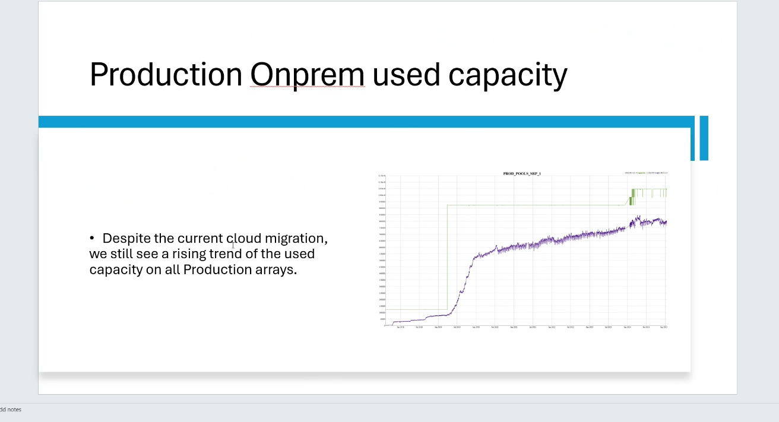  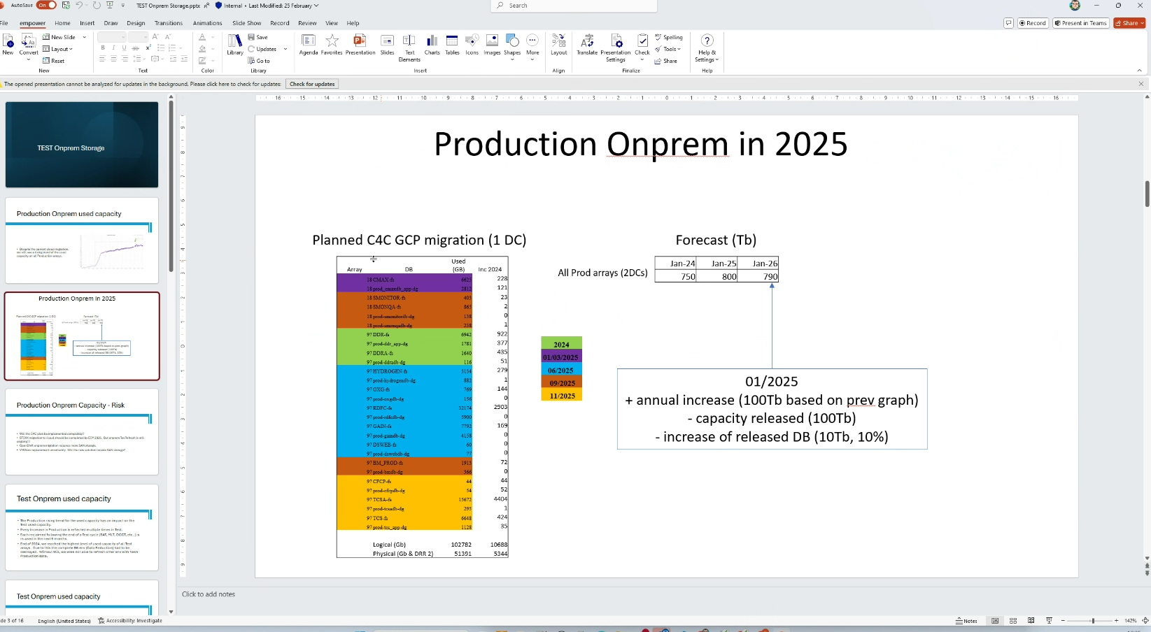  IA held a meeting with Helge Herren (Head of Xetra/Eurex Operations) on 12.02.2025 to inquire XEOPS Storage management for Eurex/Xetra Server operations. Storage monitoring is part of the general system health checks in place for all production servers. Eurex/Xetra server operations manages two types of operating system classes, Linux/Unix servers and OpenVMS servers. For Linux/Unix systems the primary monitoring tool is checkmk, for OpenVMS systems CockpitManager. | Ok, no exception identified.
TP2 | XEOPS:  IA has been informed that monthly KPI reports are shared with the team preparing the Trading Steering Committee where it is part of the reporting (Capacity Management Governance in Trading IT). Sampled 5 Monthly Reports are here.  Trading IT Environments are monitored continuously with XEOPS Cockpit Manager (AID2037) and Checkmk (AID2038) apps. Additionally, for capacity monitoring Grafana dashboard is being used.  Checkmk is the inventory functionality, which scans a server, when it is registered in Checkmk and automatically creates appropriate service checks. Concerning storage management these contain files system and volume checks. Each of these service checks monitors its associated entity for an expected status. In the context of storage management these are:  - For all mounted volumes found in the discovery a service check is created which permanently monitors the mount status of the volume. An alert is raised if the volume is not mounted.  - For all file systems provided via NFS a service check is created which monitors permanently the status of the network file system. An alert with level “critical” is raised if the NFS file system is not available.  - A special case are volumes used in a (Red Hat or Veritas) cluster setup. Such a cluster consists of two nodes, but the storage volume is always only visible on one of the two. If this server fails, the storage volumes will automatically fail over to the second server in the cluster. To cope with this situation a special cluster object is created with service checks for all clustered resources, including clustered storage volumes.  - For all file systems on volumes a service check is created which checks the used space on the file system. Events are raised in the monitoring application when the file system utilization exceeds predefined thresholds.  System health of all production servers is monitored via the CockpitMgr application from EuroVMS1. Concerning storage devices, the tool checks both for availability of disk devices as well as disk space consumption. The configuration contains four different thresholds of increasing severity from Warning, Minor, Major to finally Critical. If a threshold is breached a colour coded message is reported in the CockpitMgr GUI. Warnings are displayed in yellow, minor breaches in orange, major breaches in violet and critical events in red. The message is only cleared from the GUI if the disk space consumption is below the threshold again.  Sampled email notifications for Disk Usage of T7 reports were obtained.  Conclusion: OK  Mainframe:  IA has been informed that on a monthly basis, Mainframe Operations compiles a report called the “Production Report of Mainframe Operations”, which contains KPIs concerning availability of the IBM mainframe systems, underlying LPARs and business volume including system utilization and load stress in view of the system and application with current and previous month’s system CPU utilization. IA sampled April 2024 and September 2024 Reports and observed that 100% availability were achieved for the mainframe applications and no capacity problems occurred.  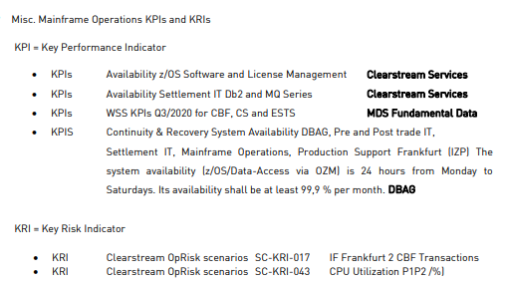  Conclusion: OK  Open Systems:  The Storage team provides the requested storage as described in the Storage request. To perform the Storage Setup, the Storage team uses different configuration tools depending on the type of storage:  - Solutions Enabler CLI for DellEMC VMAX  - Unisphere for DellEMC UNITY  - embedded GUI for DellEMC Isilon  - embedded GUI for DellEMC ECS  - Brocade SANNav or CLI for Brocade switches  - OnCommand or CLI for NetApp equipment  Storage management workflow:  For Luxembourg and DBAG Quarterly Capacity Planning meetings are done and IA sampled 2024 Q3 presentation and 2024 Q4 Capacity Planning Meeting. Also IA received latest annual capacity meeting notes for DBAG.  IA observed that continuous monitoring is done via below dashboard. If defined threshold is not maintained automatic email alerts are raised.  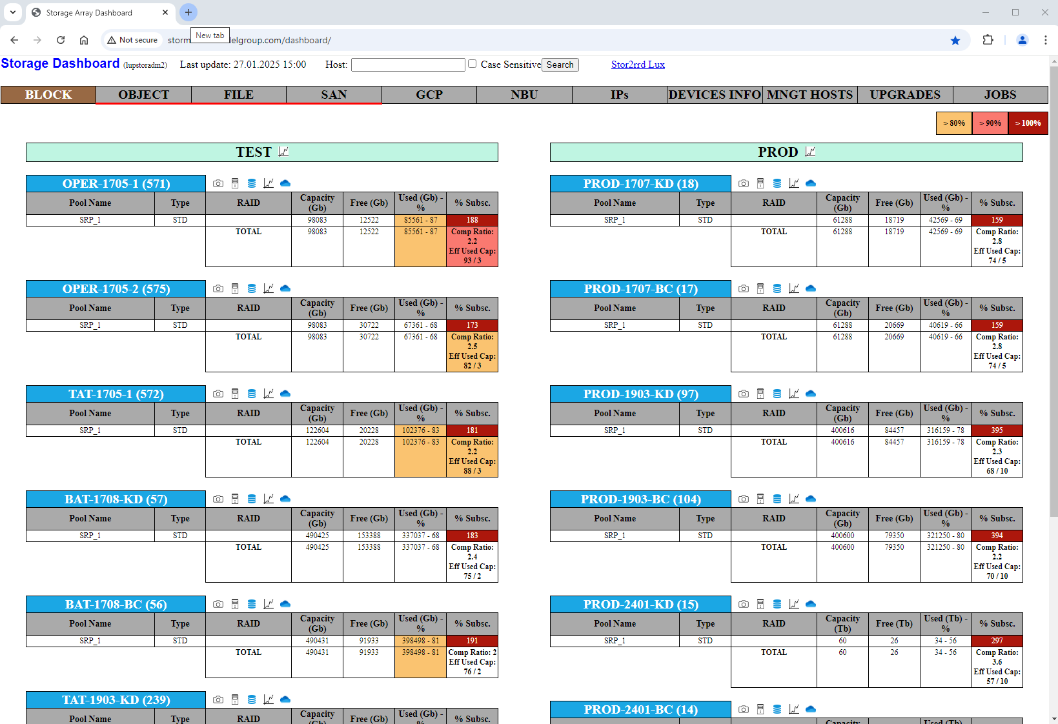  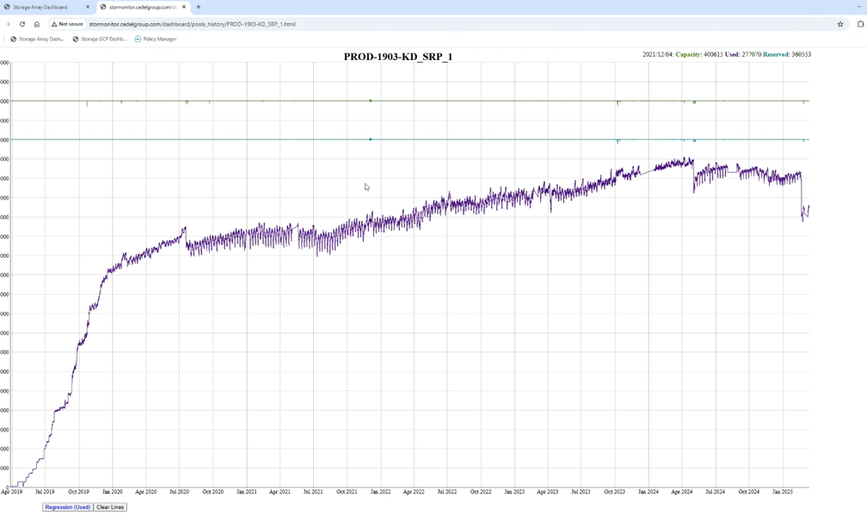  Conclusion: OK | Ok, no exception identified.
TP3 | XEOPS:  IA obtained latest XEOPS - Storage Management Overview and Process Description and XEOPS Monitoring 2024. IA noted that Eurex/Xetra server operations manages two types of operating system classes, Linux/Unix servers and OpenVMS servers. These operating systems expose different interfaces to the outside, also two different monitoring systems are in use, which take these into account. For Linux/Unix systems the primary monitoring tool is checkmk (AID2038), for OpenVMS systems Cockpit Manager (AID2037).  For Linux systems checkmk is used for monitoring, automatically creates appropriate service checks and alert is raised if the volume is not mounted. The below thresholds are set for the warnings:  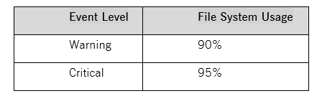  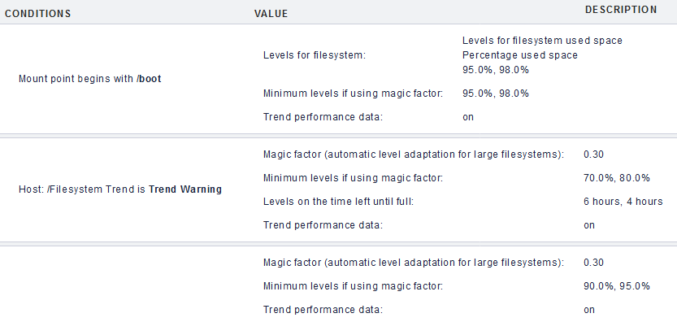  For OpenVMS Systems monitoring, system health of all production servers is monitored via the XEOPs Cockpit Manager. It contains four different thresholds of increasing severity from Warning, Minor, Major to finally Critical. If a threshold is breached a colour coded message is reported in the Cockpit Manager GUI. Warnings are displayed in yellow, minor breaches in orange, major breaches in violet and critical events in red.  All Hitachi Vantara systems in use at Deutsche Börse are monitored via the CockpitMgr application. On an on-going operational level this covers all incidents related to faulty hardware (e.g. defect disks or SAN connection issues in the fibre channel network) All thresholds are therefore set on the provisioned space (as opposed to the used space). While the systems support full usage (100%) of the available pool space, the warning threshold is set to 70% and the critical threshold to 80%.  Manage Capacity is monitored on different levels:  a) Infrastructure Level within Xetra/Eurex Operations (Dpt):  System capacity utilization (such as CPU load, disk space consumption) is continuously monitored via CheckMK. Within CheckMK thresholds are defined and in case of alerts an analysis is triggered. In case of a triggered event the follow-up is taken place according to the IT Incident Management process.  b) Application Level within Xetra/Eurex Trading IT (Dpt.)  Analysis of application specific capacity consumption is performed with the T7 Online Performance Monitor (OPM). Events are escalated to Derivatives & Cash Trading IT (Dpt.) management and documented/tracked via GitHub.  SAN Resource Monitoring (SAN RM AID2039) is a software for the automatic monitoring and documentation of all types of SAN (Storage Area Network) and its components. Whether as a troubleshooting tool, for evidence, for the daily work in the control centre, for inventorying or in change management: with SAN RM, the essential facts can be presented quickly and clearly. MEN@NET SAN RM offers a manufacturer-independent, resource-saving solution for the simple presentation of complex SAN-related issues. Because it is off shelf application there is no log forwarding on application level and no access to the appliance It is onboarded to Rapid7 for vulnerability scanning. Since it is not internet faced app there isn’t WAF implementation. RTO: 1 day < RTO <= 1 week (Security Documentation and Handbook)  Mainframe:  The Mainframe Operations, Infrastructure Support storage administrators are primarily responsible for supporting and maintaining, tape, disk and mainframe data and storage management systems. This includes ensuring sufficient capacity for daily operational and backup storage workloads and thereby maintaining the underlying storage hardware infrastructure components. As well, warranting that adequate disaster recovery procedures are in place and yearly tested. Workloads includes classic z/OS and zLinux systems deploying IBM DFSMS/HSM, BMC Database Tools, and FDR/ABR on z/OS and the distributed IBM Tivoli Storage Managers backup servers (zLinux) for numerous IBM Tivoli Spectrum Protect backup clients including e.g. the SAP Operations backup workloads. Quarterly storage reports reflecting capacity request management and changes to the storage systems are located at H:\DBS\sb2\SYS-TECH\DASD. (Ref: Mainframe Operations Organisation Handbook pg:133)  2024 Q3 Storage Report for Capacity Utilization document was received and examined.  IA has been informed that on each business working days (holidays excluded) at 08:00, there is daily production meeting with the Mainframe Operations team leads to review and discuss issues from the previous day, this includes workload and capacity performance figures of the previous day or actual market events that might increase transaction workload activities. To obtain a proper overview and understanding of the upcoming capacity requirements for the different business applications running on the Mainframe or supported by mainframe operations and to align on the annual IT budget, yearly “capacity and performance management meetings” are conducted with the business application specific stakeholders. (Capacity Performance Management Meetings)  Open Systems:  The Storage team performs a quality check on the storage request notification received from a Requester. This notification includes a specification of the desired Storage setup. In the case that the notification is incomplete, the Storage team informs the Requester that the quality check has failed. In the case that the quality check is successful, the Storage team proceeds to the next task, namely Perform Storage setup. A Storage request consists of the following elements: - Environment details (Production / Test) - Hostname where/how (single host, cluster, master-stby, ESX) the storage is added/removed - Storage capacity to add or remove In Luxembourg, a Storage request is issued in the SAP Change Management tool CRM7 for a host in Production. For hosts in Test, the storage request is issued in MAIA tool (Jira). In Frankfurt, a Storage request is received via email. An urgent Storage request can be also raised by phone. A change request in the SAP Change Management tool CRM7 is created afterwards. In MAIA, the request management tool for Test environment, the storage request contains the essential information for execution and is not subject to additional control or approval prior to submission to storage team. In CRM7, the SAP Change Management tool for production, the storage request is more detailed (description, justification, failback solution…), contains a task to be verified and accepted by the storage team, is submitted to approvals from different teams depending on its nature and impact, and finally to approval from CAB (Change Advisory Board) before execution by storage team. (ref: Storage Management v1.05)  For Luxembourg Quarterly Capacity Planning meetings are done and IA sampled 2024 Q3 presentation. Also IA received latest annual capacity meeting notes for DBAG.  Storage management workflow: | Ok, no exception identified.
TP4 | XEOPS:  Cockpit Manager (server and storage technical status OpenVMS and Linux) tool indicates standard events and incidents which need attention by the system administration team, the read only view for operations is used to correlate application issues with HW incidents.  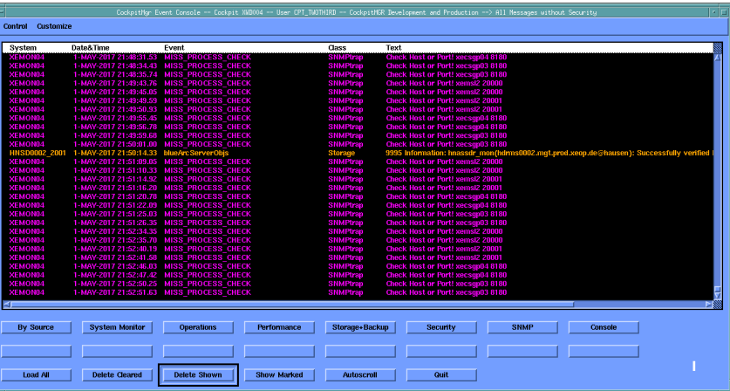  checkMK (server and storage plus application, Linux) tool indicates incidents on the technical level, which need attention.  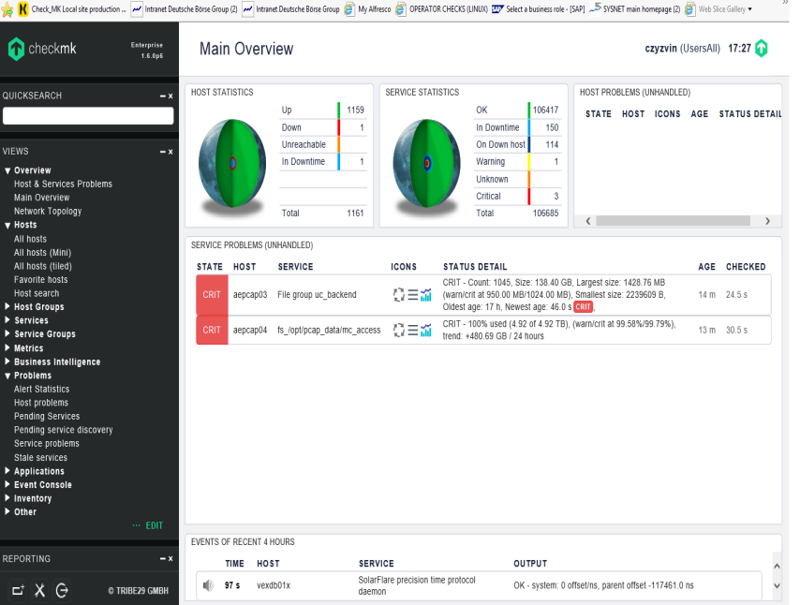  In case of an Incident the production team has to create an Incident ticket in CRM7 directly or via the BlueBook Interface. The BlueBook Interface is used to allow quick ticket entries containing secure production information, all entered tickets are forwarded directly to the company wide CRM7 system.  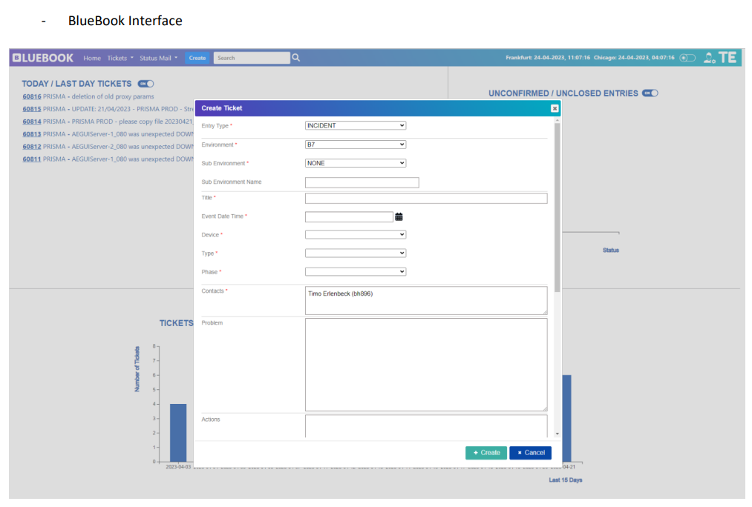  Conclusion: OK  Mainframe:  IA reviewed Mainframe Operations Organisation Handbook and observed following monitoring for mainframe operations:  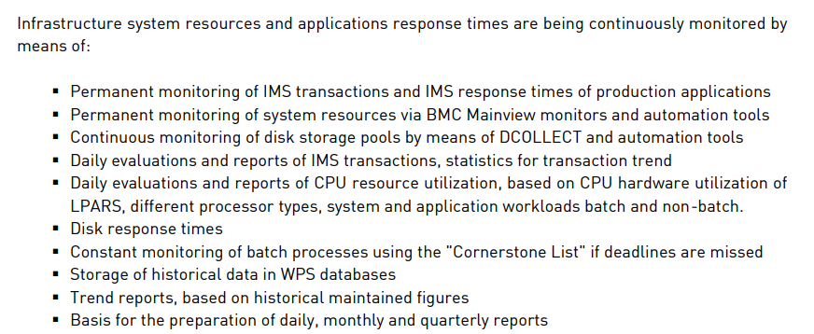  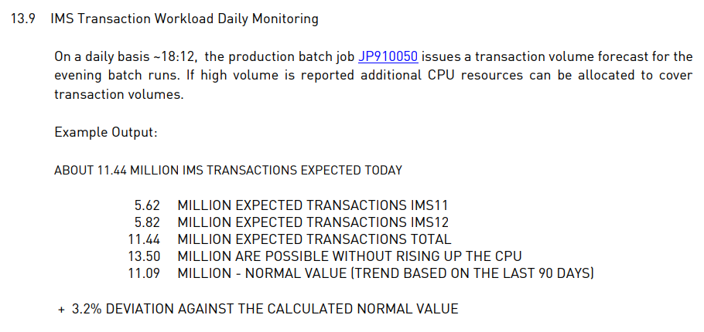  Mainframe Operations practices a strict maintenance strategy, ensuring where possible sufficient testing of new to be implemented or maintenance upgrades of hardware, software, middleware, and database components is conducted before going into production. Changes are announced and approved via the IT Change Management Process using SAP CRM.  Changes to applications are managed in JIRA. To request changes (program or IMS control block changes) in production environment, application development opens an order in Lotus Notes database “Weekly Change Management” (WCM). The workflow in this database ensures a complete processing of the order and documents all changes. Mainframe Operations, IMS Support executes the deployment and processes the WCM order.  IA has been informed that during the audit period there was no capacity alerts raised for the mainframe production environments There were no incidents, incident tickets or production impact, which would indicate an issue related disk shortage of storages resources. (evidence)  The following screenshot shows how monitoring is performed on a mainframe system with thresholds and alerts:  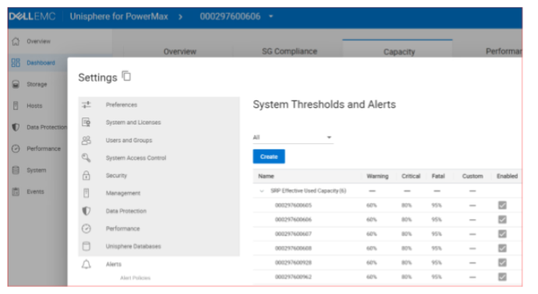  Conclusion: OK  Open Systems:  IA observed that capacity monitoring is done via below dashboard. If defined threshold is not maintained automatic email alerts are raised. IA received a sample of email notification.  Conclusion: OK | Ok, no exception identified.
TP5 | XEOPS:  IA observed that monitoring on Linux servers are performed via checkMK application and received an automatically raised alert sample and sample report including various checks. In case of an Incident the production team must create an Incident ticket in CRM7 directly or via the BlueBook Interface. The BlueBook Interface is used to allow quick ticket entries containing secure production information, all entered tickets are forwarded directly to the company wide CRM7 system.  IA obtained the full List of incidents that raised in 2024 from BlueBook. In the list 938 incidents were raised and in detail 75 Low and 863 Medium rated incidents. it also consists of the following fields: environment, event time, priority, confirmation, sapTicket number, device and title. All of the incidents are solved and has a unique sapTicket numbers.  IA also received the extract from the full 2024 Jira Storage Requests.(XEOPS-6254, XEOPS-7610 obtained and observed that requests are completed)  Conclusion: OK  Mainframe:  Monitoring is done via DELL EMC systems; it is documented in TP4. IA received the list of 2024’s Storage Requests for mainframe infrastructure. IA sampled two storage requests and obtained the relevant documentations and approvals. (ZSPACADM-95, ZSPACADM-71)  Conclusion: OK  Open Systems:  Monitoring is done via dashboard; it is documented in TP4. IA received the list of storage requests in production for Open Systems (Lux + Fra). IA sampled five storage requests and obtained relevant documentations and approvals. (PaaS Storage team- Sample evidence)  Conclusion: OK | Ok, no exception identified.

Procedures / Criteria / documents used:
Links

Caveat: All notes in this document do not represent a protocolary transcript or quotations of the meetings. They rather provide an overview over the content of the meeting. Further the notes may be arranged according to the topics discussed and not based on the chronological course of the meeting.

